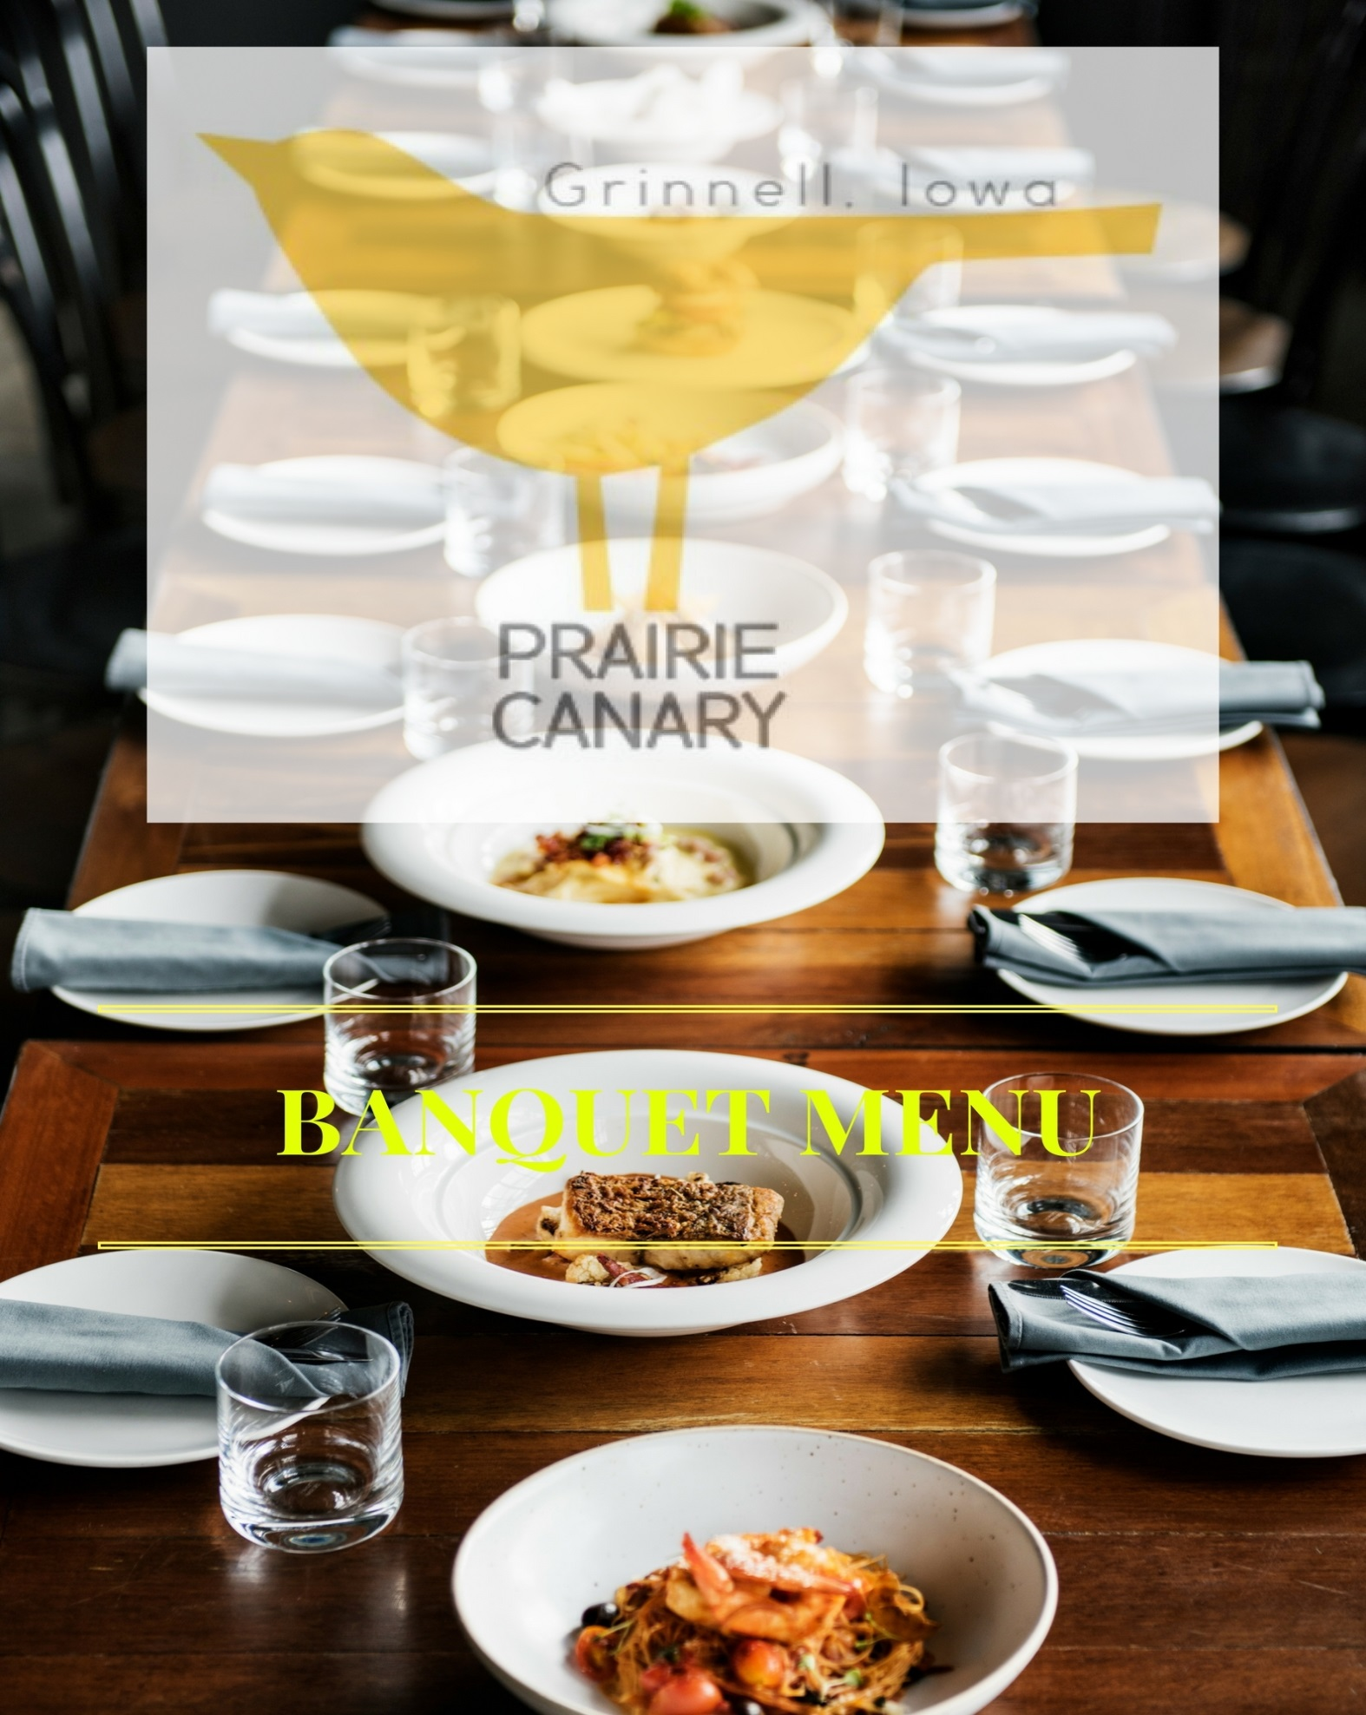

Thank you for allowing the Prairie Canary to be a part of your special occasion. The banquet service is an extension of Prairie Canary; therefore, we take great pride in the quality and presentation of our food and service. This packet is merely a starting point, we will work with you to stay within your budget and accommodate your requests.

Non-Alcoholic Beverage Service à la carte

Canned Soda (Coca-Cola) $2.50 each
Fresh Brewed Regular & Decaffeinated Coffee $14.95 per gallon
Fresh Brewed Iced Tea $12.95 per gallon
Lemonade $12.95 per gallon
Fresh Juices (Orange or Cranberry) $12.95 per gallon
Prairie Canary Juice Cans $2.50 each
Bottled Water $2.00 each

Iced Tea, Coffee $1.99 per guest
Coffee, Juice $2.50 per guest
Coffee, Iced Tea, Canned Soda $3.00 per guest

Hors d’ oeuvres
A minimum of 12 guests

Fresh Sliced Fruit Display $4.99 per guest
International & Domestic Cheese Display $5.99 per guest
Fruit Garnish | Crackers

Assorted Cocktail Sandwiches $21.99 per dozen
Ham | Turkey | Roast Beef | Cheese | Condiment

Bruschetta $3.99 per guest
Tomatoes | Garlic | Olive Oil | Asiago | Baguettes

Hummus $4.99 per guest
Fried Naan |Red Peppers | Green Peppers | Carrots

Antipasto Display $9.99 per guest
Cured Meats | Assorted Cheeses | Olives |
Grilled Vegetable Chef’s Selection of Dips | Dried Fruits |
Artisan Breads | Fresh Fruit

Whole Smoked Salmon $12.99 per guest
Diced Eggs | Red Onions | Cream Cheese |
Capers | Baguettes

Spinach & Artichoke Dip $4.99 per guest
Fried naan

Guacamole $4.99 per guest
Fried tortilla chips

Queso Blanco $4.99 per guest
Fried tortilla chips

Hors d’ oeuvres
A minimum order of 2 dozen each

Mini Crab Cakes $24.99 per dozen
Maryland Style | Cilantro Lime Aioli

Brochettes: (minimum order of 2 dozen per choice) $22.99 per dozen
Meats: Beef | Chicken | Pork
Sauces: Honey Chipotle | BBQ | Teriyaki | Thai Peanut

Meatballs $17.99 per dozen
Sauces: Honey Chipotle | BBQ | Teriyaki | Swedish

Fried Chicken Tenders $22.99 per dozen
Sauces: Honey Chipotle | BBQ | Teriyaki | Buffalo

Stuffed Mushrooms (minimum order of 2 dozen per choice) $19.99 per dozen
Italian | Crab | Spinach & Gorgonzola

Crab Rangoon $15.99 per dozen
Sweet & Sour Sauce | Honey Chipotle

Egg Rolls (minimum order of 2 dozen per choice) $15.99 per dozen
Meats: Vegetable | Pork
Sauces: Sweet & Sour Sauce | Honey Chipotle

Meatball Marinara Sliders $9.99 per dozen

Reuben Sliders $9.99 per dozen

Crab Deviled Eggs $18.99 per dozen

Large Gulf Shrimp (Cocktail Sauce) $2.99 per shrimp*

Assorted Crostini $9.99 per dozen

Lox Salmon and Cream Cheese
Cream Cheese | Salmon | Capers

Brussel Sprouts and White Cheddar
Brussel Sprouts | White Cheddar | Garlic

Bacon and Caramelized Onion
Bacon | Caramelized Onions | Blue Cheese | Honey

Prosciutto - Pear
Goat Cheese | Prosciutto | Pear | Spiced Pecans

BLT
Heirloom Tomato | Applewood Smoked Bacon | Heart of Romaine | Aioli

Brie and Apples
Brie | Gala Apple | Honey

Carving Station
Served with warm rolls

Carved Sirloin $9.99 per guest
Horseradish Sauce

Carved Beef Tenderloin $19.99 per guest
Horseradish Sauce

Carved Turkey Breast $6.99 per guest
Dijon & Mayonnaise

Carved Brown Sugar Glazed Ham $7.99 per guest

Carved Pork Loin $7.99 per guest
Horseradish Sauce

Carved Prime Rib $18.99 per guest
Horseradish sauce & Au Jus
Plated Dinners
Comes with choice of soup or salad and dinner rolls

Grilled Salmon $22.99
Shrimp and Asparagus Risotto | Red Onion Vinaigrette
Skillet-Roasted Halibut Steak $23.99
Artichokes | Wild Mushrooms | Tomato Confit | Sauvignon Blanc Essence
Lemon Pepper Salmon $21.99
Jonah Crab Meat | Chardonnay Chive Butter Sauce | Saffron Rice
Bacon Wrapped Scallops $22.99
Cauliflower Purée | Braised Romaine | Cabernet Reduction
Almond Encrusted Salmon $22.99
Superfoods Salad (Quinoa, Beets, Kale, Pomegranate, Avocado)
Grilled Filet Mignon $24.99
Sauces: Roquefort Butter | Béarnaise Sauce | Artichoke Tomato Ragout |
Wild Mushroom Demi-Glace
Prime Rib of Beef Au Jus $23.99
Starch Side Choices (1): Roasted Fingerling Potatoes | Parmesan Mashed Potatoes
Vegetable Side Choices (1): Wild Rice & Vegetable Medley | Buttered Baby Carrots | Steamed Asparagus
Grilled Sirloin $21.99
Starch Side Choices (1): Roasted Fingerling Potatoes | Parmesan Mashed Potatoes
Vegetable Side Choices (1): Wild Rice & Vegetable Medley | Buttered Baby Carrots | Steamed Asparagus

Steak au Poivre $22.99
Five-Pepper Blend | Cognac Cream Sauce

Plated Dinners Continued
Comes with choice of soup or salad and dinner rolls

Lamb Chops $27.99
Dijon Rosemary Crust | Minted Demi-Glace
Starch Side Choices (1): Roasted Fingerling Potatoes | Parmesan Mashed Potatoes
Vegetable Side Choices (1): Wild Rice & Vegetable Medley | Buttered Baby Carrots | Steamed Asparagus
Roast Boneless Duck $22.99
Braised Brussel Sprouts | Red Wine Balsamic Reduction
Roast Tenderloin $27.99
Sliced & Served with a Bordelaise Sauce
Starch Side Choices (1): Roasted Fingerling Potatoes | Parmesan Mashed Potatoes
Vegetable Side Choices (1): Wild Rice & Vegetable Medley | Buttered Baby Carrots | Steamed Asparagus
Lemon Herb Chicken $20.99
Starch Side Choices (1): Roasted Fingerling Potatoes | Parmesan Mashed Potatoes
Vegetable Side Choices (1): Wild Rice & Vegetable Medley | Buttered Baby Carrots | Steamed Asparagus
Chicken Roulade $22.99
Spinach, Fontina Cheese | Lemon Thyme Jus
Starch Side Choices (1): Roasted Fingerling Potatoes | Parmesan Mashed Potatoes
Vegetable Side Choices (1): Wild Rice & Vegetable Medley | Buttered Baby Carrots | Steamed Asparagus

Vegetarian Selections
Comes with choice of soup or salad and dinner rolls

Vodka Pasta $16.99
Red & Green peppers | Crushed Red Pepper | Ziti

Fettuccini Alfredo $15.99

Spinach Lasagna $16.99
Spinach | Mushrooms | Ricotta Cheese | Provolone | Mozzarella

Eggplant Parmesan $16.99
Breaded eggplant | Mozzarella | Angel Hair | Marinara

Pasta Primavera $16.99
Zucchini | Yellow squash | Red & Green peppers | Red onion | Ziti

Soup Choices:
Choice 1

Tomato Feta | French Onion | Clam Chowder
Chicken and Wild Rice | Bayou Chowder | Beer Cheese

OR

Salad Choices
Choose 1

Canary
Greens | Apricot Dill Dressing | Cherry Tomatoes | Sunflower Seeds | Grated Parmesan

Kale
Kale | Orange-Ginger Vinaigrette | Feta | Roasted Corn | Roasted Beets | Black Quinoa

Apple
Greens | Champagne Vinaigrette | Apples | Blue Cheese | Dried Cherries | Spiced Almonds

Pear
Greens | Poppy Seed Dressing | Pears | Roasted Beets | Feta

Dinner Buffet
1 entrée choice $21.99 / 2 entrée choices $27.99 / 3 entrée choices $35.99
Buffet includes choice of 2 starches / 2 vegetables / 2 salads

Seafood-Stuffed Haddock
Sauces: Lobster sauce OR Lemon Herb Butter

Oven-roasted Chicken
Truffle Mushroom Sauce

Grilled OR Pan-seared Salmon
Wilted Spinach | Red Onion Tomato Vinaigrette

Grilled OR Blackened Swordfish
Lemon Herb Butter | Fresh Fruit Salsa OR
Au Poivre with Five-Pepper Blend | Ratatouille

Grilled Salmon Au Poivre
Five-Pepper Blend | Ratatouille

Horseradish Haddock
Crusted with Horseradish and Panko | Fried Leeks | Chive Mashed Potatoes

Pecan-Crusted Salmon
Apple Cider Brown Butter

Chicken Schnitzel
Lemon Caper Butter

Chicken Roulade
Spinach | Fontina Cheese | Lemon Thyme Jus

Monterey Chicken
Jack Cheese | Avocado | Sun-Dried Tomato Coulis
Dinner Buffet Continued
1 entrée choice $21.99 / 2 entrée choices $27.99 / 3 entrée choices $35.99
Buffet includes choice of 2 starches / 2 vegetables / 2 salads

Asian Barbequed Chicken
Fried Rice | Snow Peas | Carrots | Bean Sprouts | Mushrooms

Chicken Marsala
Mushroom Marsala Demi-Glacé

Chicken Oscar
Crabmeat | Asparagus | Béarnaise Sauce & Demi-Glacé

Roast Sliced Sirloin
Mushroom Madeira Demi-Glacé OR Bordelaise Sauce

Sirloin Tips
Shallots | Mushrooms | Tarragon Brown Sauce

Char-Grilled Sirloin Tips
Grilled Onions | Peppers | Mushrooms | Red Wine Jus

London Broil
Marinated & Grilled to Medium Rare | Sliced

Roasted Pork Loin
Roasted Shallots | Oven-Dried Tomatoes | Red Wine Sauce

Roasted Pork Loin
Cajun Oyster Cornbread Stuffing | Cabernet Pan Gravy

Roasted Pork Loin
Apple Marmalade | Bourbon Sweet Potatoes

Vegetarian Buffet Selections
1 entrée choice $21.99 / 2 entrée choices $27.99 / 3 entrée choices $35.99
Buffet includes choice of 2 starches / 2 vegetables / 2 salads

Vodka Pasta
Red & Green peppers | Crushed Red Pepper | Ziti

Fettuccini Alfredo

Spinach Lasagna
Spinach | Mushrooms | Ricotta Cheese | Provolone | Mozzarella

Eggplant Parmesan
Breaded eggplant | Mozzarella | Angel Hair | Marinara

Pasta Primavera
Zucchini | Yellow squash | Red & Green peppers | Red onion | Ziti

Sides
Circle options

Starch (Choose 2) | Vegetable (Choose 2)
Scalloped Potatoes  Potato Casserole  Twice Baked Potatoes  Parmesan Fingerling Potatoes  Buttered Baby Red Potatoes  Mashed Potatoes and Gravy  Rice Pilaf  Wild Rice | Asparagus with Hollandaise  Vegetable Medley  Broccoli with cheese sauce  Buttered Green Beans  Country Green Beans  Green Bean Casserole  Steamed Cauliflower with Cheese Sauce
Cold Items (Choose 2)
Tossed Salad

Pasta Salad

Fruit Arrangement

Quinoa Salad

Broccoli Salad

Cucumber Salad

Greek Orzo Salad

Tomato Basil Feta Salad

Continental Breakfast Selections

Traditional Continental Breakfast (minimum of 20 guests) $6.99 per guest
Fresh Baked Pastries | Bagels & Cream Cheese Coffee | Orange Juice | Cranberry Juice

Deluxe Continental Breakfast (minimum of 20 guests) $8.99 per guest
Fresh Baked Pastries | Bagels & Cream Cheese | Sliced Fruit | Coffee | Orange Juice | Cranberry Juice

Breakfast Buffet Breakfast Buffet (minimum of 20 guests)
(1) Entrée $10.99 per guest
(2) Entrées $12.99 per guest

Entrée Selections:
Fluffy Scrambled Eggs | Classic Biscuits & Gravy | French toast with Warm Syrup & Butter |

Scallions Breakfast Casserole – Choose up to (3) ingredients:
Breakfast Sausage, Bacon, Ham Spinach, Tomatoes, Onions, Mushrooms, Peppers, Cheddar Cheese, Swiss)

Choice of (2) Proteins
Bacon | Ham | Sausage Links | Sausage Patties

Choice of (2) Sides
Hash Browns | Lyonnaise Potatoes | Sliced Fruit | Brown Sugar Oatmeal Flavored

Breakfast buffet is served with assorted pastries, fresh brewed coffee and assorted juices

Dessert

Blondie Sundae $5.99
Vanilla bean ice cream & spiced pecans

Flourless Chocolate Torte $5.99
Fresh berries & berry compote

Carrot Cake $5.99

Triple Chocolate Mousse Cake $5.99

Wild Berry Short Cake $6.99
Berries foster & vanilla bean ice cream

High Rise New York Cheese Cake $6.99
Topped with fresh berries

Cannoli $5.99
Strawberry cannoli cream & fresh berries

Prairie Canary Banquet / Catering Contract
This Catering Contract is entered into between Prairie Canary Restaurant and ___________________________ and sets forth the agreement between the parties relating to catering services to be provided by the Caterer for Client for the event identified in this Contract.
1. Event details
Client is hiring Caterer to provide food and beverages, and related services, for the following event:
Event Name ________________________________________
Client Name(s) ________________________________ Client Number__________________
Client Email __________________________________
Today’s Date ________________________________________
Event Date __________________________________________
Event Time (for guests): _________________ Event Start Time: ______________________
Event End Time (for guests): ______________________________
Location of Event: ___________________________________________________________________
Facility Contact Person: ____________________ Contact Number: _____________________
Estimated number of guests: __________

2. Menu to be served
The Parties have agreed to the menu attached to this Catering Agreement as Exhibit A. Caterer reserves the right to make small changes to the menu if key ingredients are unable to be sourced due to reasons beyond the control of the Parties. The following limitations will apply to this reservation of right — [LIMITATIONS ON MENU ALTERATIONS].
No alcoholic beverages will be served without a separate agreement relating thereto.
3. Coordination with venue
Prairie Canary will need to have access to the Venue no later than ____________ hours in advance of the Start Time for the Event, and _____________ hours after the End Time for clean-up. Client will make all necessary arrangements, at Client’s expense, to get this access arranged.
4. Payment terms
In exchange for the services of Caterer as specified in this Catering Contract, Client will pay to Caterer ____________ per person attending the event, but in no event less than the Guest Count provided by Client to Caterer 5 days in advance of the event. As of the signing of this Contract, the total amount is estimated to be $_____________________ (“Estimated Total Cost”).
Payment will be made to the Caterer as follows: $500 deposit due on the date of signing, and the balance of approximately will be due on 5 days in advance of the event. The exact amount due will be determined, and provided from Client to Caterer in writing, one week in advance of the Event along with a final guest count.
5. Responsibilities for related costs
Client is solely responsible for all costs and/or deposits relating to use of the Venue, and for obtaining any necessary permissions, authorizations, or other requirement of Caterer providing services at the Venue.

6. Insurance and indemnification
Caterer has, or will obtain, general liability insurance relating to Caterer’s services at the Event. However, Client will indemnify and hold harmless Caterer for any damage, theft, or loss of Caterer’s property occurring at the event, causes by any of Client’s guests.
7. Cancellation
If the Client needs to cancel the event, Client must provide written notice to Caterer along with any required cancellation fee described in this Catering Contract, to effect cancellation.
Client understands that upon entering into this Contract, Caterer is committing time and resources to this Event and thus cancellation would result in lost income and lost business opportunities in an amount hard to precisely calculate. Therefore, the following cancellation limitations will apply. If Client requests cancellation of this Contract 90 days or more before the Event, Caterer shall be entitled to 20 percent of the Estimated Total Cost. If Client requests cancellation 45-89 days before the Event, Caterer shall be entitled to 40 percent of the Estimated Total Costs. If Client requests cancellation 31-44 days before the Event, Caterer shall be entitled to 70 percent of estimated cost of event. After 30 days in advance of the Event, Caterer shall be entitled to 100 percent of the Estimated Total Cost.
The Client’s deposit will be credited against the cancellation fees owed. Any balance will be payable upon the notice of cancellation.
8. Legal compliance
Caterer will work in compliance with all applicable local health department rules and regulations relating to food preparation and food service.
9. Assignment
This Contract cannot be assigned by either Party without the other’s written consent, with the exception set forth in paragraph 10, below.

10. Limitation of remedies
If Caterer cannot fulfill its obligations under this Contract for reasons outside of its control, Caterer may locate and retain a replacement catering company at no additional cost to Client, or refund Client’s money in full. Caterer will not be responsible for any additional damages or compensation under these circumstances.
11. Resolution of disputes
The Parties agree to not post any negative information about the other arising out of this Contract or Event on any online forum or website without providing advance written notice of the intended content thereof, and providing the other party with an opportunity to resolve any issues between the parties amicably.
12. Jurisdiction and Venue
This Contract will be interpreted according to the laws of the State of Iowa and any legal action must be filed in the County of Poweshiek in the State of Iowa.
13. Entire Agreement
This document, along with its exhibits and attachments, constitutes the entire agreement between the Parties.
Executed on: Today’s Date __________ Executed on: Today’s Date ________
Caterer Client
_______________________________ ________________________________

Prairie Canary Restaurant
924 Main Street Grinnell, Iowa 50112 641-236-0205
CLIENT_______________________________________
CLIENT ADDRESS______________________________
City _____________ State ____________ Zip ________
Contact Number ________________________________
Email _________________________________________

Banquet Menu Worksheet
City |  |  |  |  | State |  |  |  | Zip
 | Hors d' Oeuvres |  |  |  | Amount/ Count |  | Cost |  | Buffet
1 |  |  |  |  |  |  | $
2 |  |  |  |  |  |  | $ |  | Entree 1
3 |  |  |  |  |  |  | $ |  | Entree 2
4 |  |  |  |  |  |  | $ |  | Entree 3
5 |  |  |  |  |  |  | $
6 |  |  |  |  |  |  | $ |  | Starch 1
8 |  |  |  |  |  |  | $ |  | Starch 2
9 |  |  |  |  |  |  | $
10 |  |  |  |  |  |  | $ |  | Vegetable 1
 |  |  |  |  |  |  |  |  | Vegetable 2
 | Plated |  |  |  | Amount/ Count
 |  |  |  |  |  |  | Cost
1 |  |  |  |  |  |  | $ |  | Cold Item 1
2 |  |  |  |  |  |  | $ |  | Cold Item 2
3 |  |  |  |  |  |  | $
4 |  |  |  |  |  |  | $ |  | Hors d' Oeuvres
5 |  |  |  |  |  |  | $
 |  |  |  |  |  |  |  |  | 1
 | Salad Choice |  |  |  |  |  |  |  | 2
1 |  |  |  |  |  |  |  |  | 3
2 |  |  |  |  |  |  |  |  | Dessert
 | Soup Choice |  |  |  |  |  |  |  | 1
1 |  |  |  |  |  |  |  |  | 2
2 |  |  |  |  |  |  |  |  |  | Number | Cost | Extended $
 |  |  |  |  |  |  |  |  | Buffet
 | Dessert |  |  |  |  |  | Cost |  | Dessert
1 |  |  |  |  |  |  | $ |  | Dessert
2 |  |  |  |  |  |  | $ |  | Appetizer
3 |  |  |  |  |  |  | $ |  | Appetizer
 |  |  |  |  |  |  |  |  | Appetizer

Notes – Special Request

